Bbnb cxSnoSDASDFGJJL’\  N /,//7XJMBGZNZ,Z N 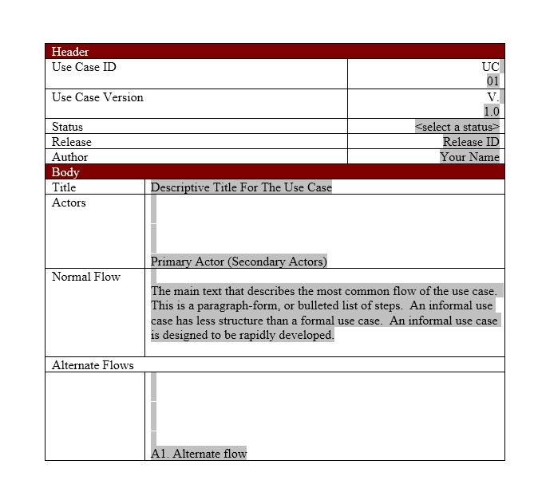 | TestCase ID | Description
1 | Tc_001 | To validate the data
2 | Tc_002 | To validate the formate of the table
3 | Tc-003 | To validate the null values of the table.

- Tc-003_01To validate the nulll values comm

- Tc_003_02To validate the null values ename,empno

- Tc_003_03To validate the null values in sal,deptno

4 | Tc_004 | To validate distinct values of empno in emp table
4.1 | Tc_004_01 | To validate distinct values of ename in emp table
5 | Tc_005_01 | To check the field value or space

6 | Tc_006_01 | To check the constraints
 |  | To check the name of the employer who has not earned
7 | Tc_007_01 | any commission
8 | Tc_008_01 | To check the row count of ename in emp
8.1
8.2
8.3
9 | Tc_009_01 | To check the max salary from emp table
10 | Tc_0010_01 | To check the min salary from emp table

Expected Result | Actual result | Status
Data should be available | Same as expected | pass
Structure should in correct formate | Structure is un evenn order | fail
null values should not be available | Same as expected | pass
10 rows should be availabel | Same as expected | pass
null values should not be available | Same as expected | pass
null values should be available | Same as expected | pass
distict values should not available | Same as expected | pass
distict values should not available | Same as expected | pass
It should be display length of the field | Same as expected | pass
It should be display constaints of the field | same as expected | pass
It should be display the employes who are not
getting any commision | same as expected | pass
It should be display 14 rows | Same as expected | pass
It should be display highest salary | Same as expected | pass
it shouls be display lowest salary | Same as expected | pass


comments
Test Data
EMPNO ENAME JOB |  | MGR HIREDATE | SAL | COMM | DEPTNO
--------- ---------- --------- ---------- --------- ---------- ---------- ----------
7369 SMITH | CLERK | 7902 17-DEC-80 | 800 | 20
7499 ALLEN | SALESMAN | 7698 20-FEB-81 | 1600 | 300 | 30
7521 WARD | SALESMAN | 7698 22-FEB-81 | 1250 | 500 | 30
7566 JONES | MANAGER | 7839 02-APR-81 | 2975 |  | 20
7654 MARTIN | SALESMAN | 7698 28-SEP-81 | 1250 | 1400 | 30
7698 BLAKE | MANAGER | 7839 01-MAY-81 | 2850 |  | 30
7782 CLARK | MANAGER | 7839 09-JUN-81 | 2450 |  | 10
7788 SCOTT | ANALYST | 7566 19-APR-87 | 3000 | 20
7839 KING | PRESIDENT | 17-NOV-81 5000 |  | 10
7844 TURNER | SALESMAN | 7698 08-SEP-81 | 1500 | 0 | 30
7876 ADAMS | CLERK | 7788 23-MAY-87 | 1100 | 20
7900 JAMES | CLERK | 7698 03-DEC-81 | 950 | 30
7902 FORD | ANALYST | 7566 03-DEC-81 | 3000 | 20
7934 MILLER | CLERK | 7782 23-JAN-82 | 1300 | 10

 | PEER REVIEW
TC ID | COMMENTS
2 | SPELLINGMISTAKE
3.1 | SPELLINGMISTAKE
4 | SPELLINGMISTAKE
4.1 | SPELLINGMISTAKE
6 | SPELLINGMISTAKE
7.1 | SPELLINGMISTAKE
10.1 | SPELLINGMISTAKE

